Fact Sheet on ROMANIA

Map
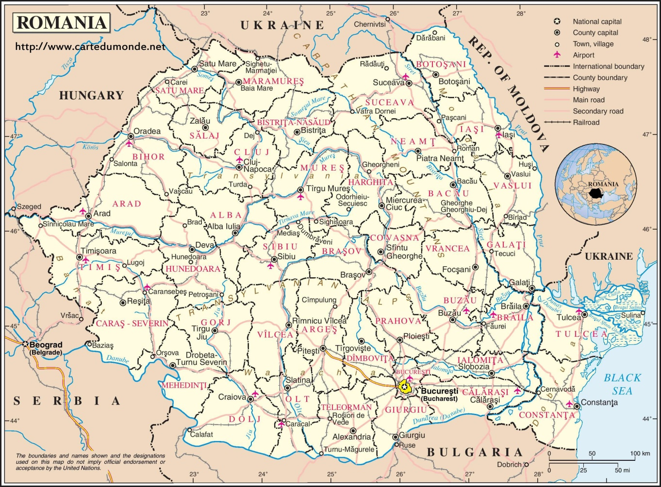
Flag

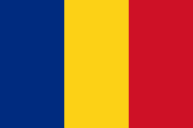
Official name: ROMANIA
National Day: December 1
Capital: Bucharest

Head of State: President H.E. Mr. Klaus Werner Iohannis
Head of Government: Prime Minister H.E. Mr. Ludovic Orban
Foreign Minister: H.E. Mr. Bogdan-Lucian Aurescu
Political and Administrative Structure: Legislative, Senators 136, Deputies 329
Administrative Divisions: 42
Area: 238,391 sq.km. (roughly the size of Uttar Pradesh)
Density: 83.6 per sq. km (2017)
Population: 19.59 million (2018)
Urban: 63.9% of the total population (2017)
Growth rate: (-) 0.28% (2017)
Life Expectancy: 75.3 years (2017)
Literacy: 92.5% (2014)
Internet Users:15 million (2018)
Other principal cities: Constanta, Iasi, Timisoara, Cluj, Galati, Brasov, Sibiu.
Coastline: 226 km
Land Boundaries: 2508 km
Railways: 10,774 km (2017)
Roadways excluding urban roads: 86,099 km (2017)
Waterways: 1,779 km
Airports: 54 (26 paved runways, 28 unpaved runways)
Heliports: 3
Ports and Terminals: Braila, Constanta, Galati (Galatz), Mancanului (Giurgiu), Midia, Tulcea

GDP: $ 239.85 billion (December 2018)

GDP (PPP) $516.33 (2018)

GDP per capita PPP: $26.446 (2018)

GDP Growth: 4.5 % (2018)
Inflation rate: 3.27 % December (2018)
Pipelines: Gas 13,350 km (2017); Oil 16,601 km (2017)
Oil Production: 3538345 tons (2017)
Natural Gas Production: 11.07 billion m³ (2017)
Industrial Production Growth Rate: 4% (2015 est/ CIA.)
Reserve of Foreign Exchange and Gold: Euro 34,845 billion (July 2018) 103.7 tons GOLD (July 2018)
Currency: RON [colloquial Lei]
Exchange Rate: US$1=RON 4.24 (approx.)

Climate: Cold, cloudy winters with frequent snow and fog; sunny summers with frequent showers and thunderstorms. Average temperature is +11° C in the plains and +2° C in the mountains. In Bucharest, during summer the average temperature is 27° C and the maximum 42° C. During winter, the average is 0° C and minimum -15° C. Temperatures during 25-28 May 2017 are likely to be in the range of 12 C to 27 C, with day temperature of 25 C and night temperatures of around 13 C.

Time: April–September: IST -2 ½ hours; October– March: IST -3 ½ hours.

Ethnic composition: Romanian 89.5%, Hungarian 6.6%, Roma 2.5%, Ukrainian 0.3%, German 0.3%, Russian 0.2%, Turkish 0.2%, other 0.4% (2002 census).

Languages: Romanian 91% (official), Hungarian 6.7%, Romany (Gypsy) 1.1%, other 1.2% Romanian. French and English are spoken fairly widely; Hungarian and German are spoken in some regions.

Religion: Eastern Orthodox (including all sub-denominations) 86.8%, Protestant (various denominations including Reformate and Pentecostal) 7.5%, Roman Catholic 4.7%, other (mostly Muslim) and unspecified 0.9%, (2011 census).

Imports : EUR 82.86 billion (2018) Common metals, electrical machines, devices and equipment; sound and image display and records, chemical and connected industries products, textiles and such articles, footwear, hats, food products, mineral products, plastic and rubber materials and such articles, agricultural products, etc .

Exports: EUR 67.73 billion (2018) Electrical machines, devices and equipment, sound and image display and records, common metals, transport vehicles and parts, chemicals and connected industries products, wood paste, paper, cardboard and its scrap, agricultural products, minerals and fuels, textiles and footwear, etc.

Natural Resources: Petroleum (reserves declining e.g. from 104,600 bbl/day in 2013, Romania produced 84000 bbl/day in 2016), timber, natural gas, coal, iron ore, salt, arable land, hydropower.

Agricultural Products: Wheat, corn, barley, sugar beets, sunflower seed, potatoes, grapes, etc.

Major industries: Electric machinery and equipment, textiles and footwear, light machinery and auto assembly, mining, timber, construction materials, metallurgy, chemicals, food processing, petroleum refining.

Major trading partners: Italy, Germany, France, UK, USA, Turkey, Russia, Austria, Hungary and China.

Membership in International Organisations: NATO, EU, OSCE, Black Sea Economic Co-operation, FAO, IAEA, ICAO, ILO, IMO, ITU, IPU, OPCW, UNCTAD, WTO, to name a few.

Indian Community: The Indian community in Romania, including PIOs and their families, numbers around 1100. There are about 110 Indian students attending courses in Romanian institutions, mainly pursuing medicine on a self-financing basis at Timisoara, Oradea, Bucharest, and Iasi. Others are businessmen, professionals and technical specialists.

06 December 2019
Bucharest, Romania

